4Sight EV7 Brackets

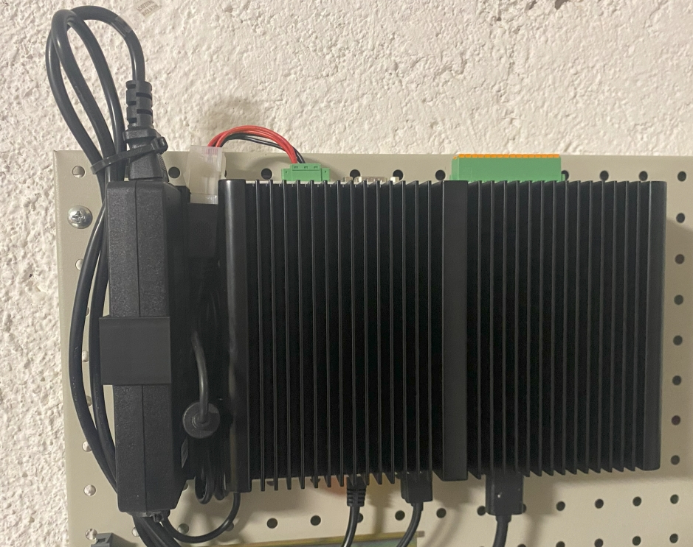

Project Goals
I need a bracket to fix the 4Sight EV7 to the wall, together with the power supply trying to keep power cables under control.

Design

4Sight EV7 Bracket sketch
This is fixed to the board and support 2 screws that are then used to lock the computer.
We need 2 of this, so I created it symmetrical.
The base size is 150x30 mm
There are 4 holes (3.80 mm) for the support screws (M4x10)
There are 6 slots for the expansion anchor (see the other project)
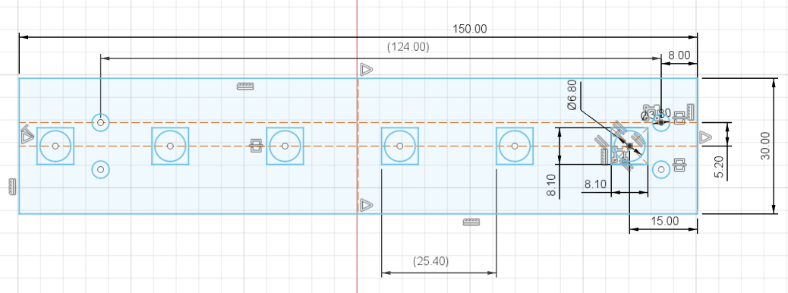

4Sight EV7 Bracket 3D Model
The extrusion height of the base is 6 mm.
In order to lock the expansion anchor in place there are 6, 4 mm deep slots.
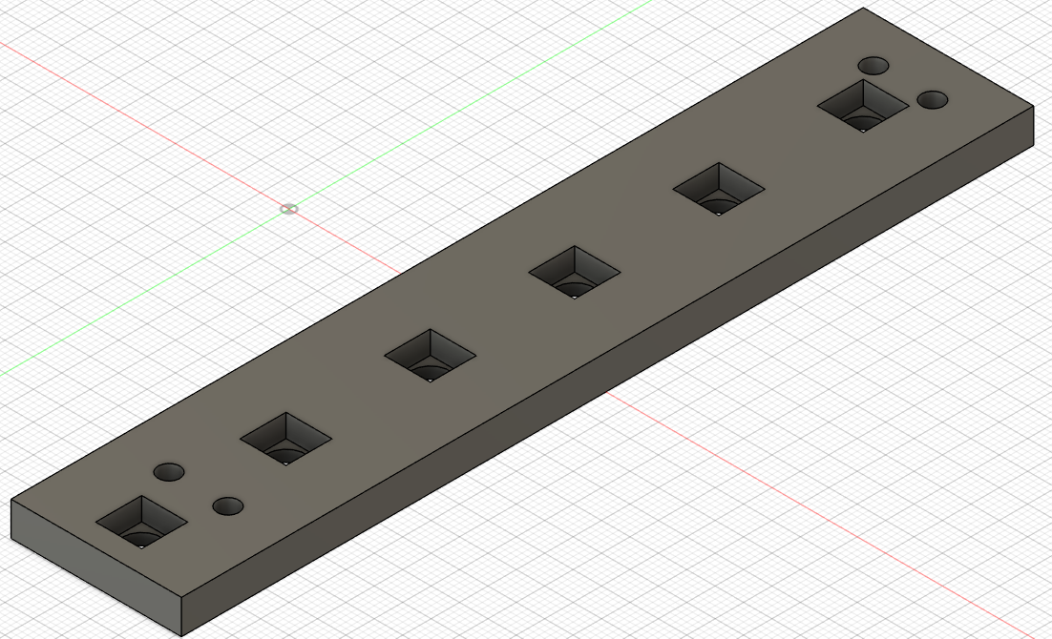

Power Supply Sketch
This is the container for the power supply.
The base size is 151x31 mm.
The container is fixed to the board using 2 expansion anchor
The back contains 6 possible position for the anchor.
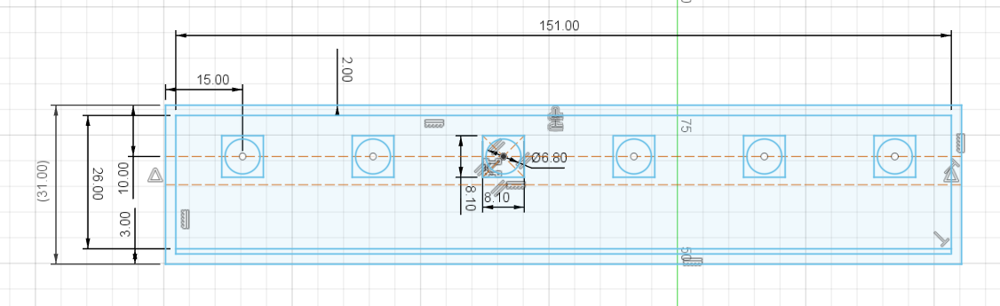
A Side slot 30 mm wide has been created to accommodate the Power Supply Lock
A 2.80 mm thread hole is used to hold the lock in place.
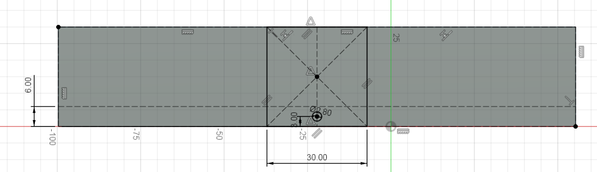

Power Supply 3D Model
The base thickness is 6 mm
The side wall is 30 mm high.
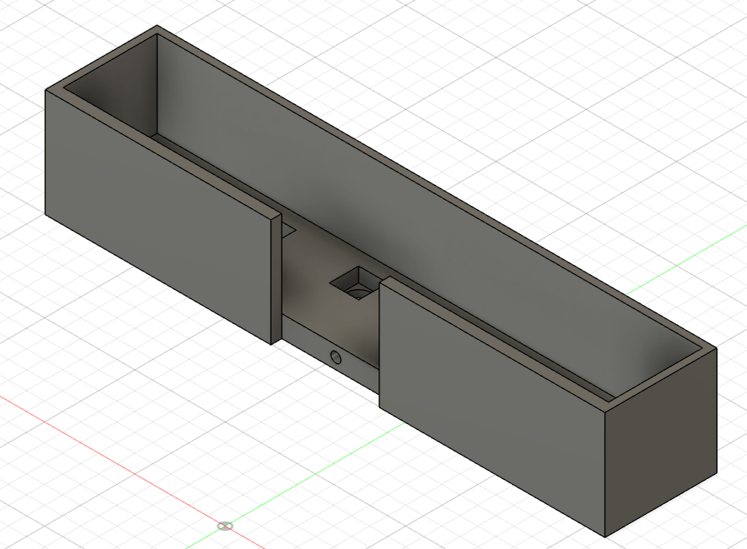

Power Supply Lock Sketch
This is an L-Shaped bracket
The base size is 77x30 mm
There is a 3,20 hole for the screw, but no recession since it is not thick enough.
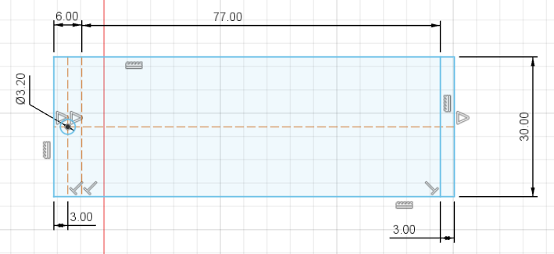

Power Supply Lock 3D Model
The lock is 3 mm thick.
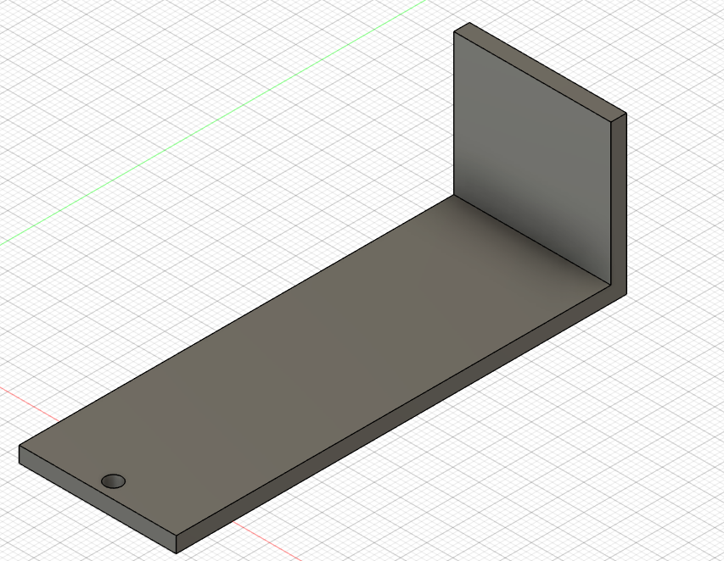

3D Printer Layout
All components can be printed in just one run.
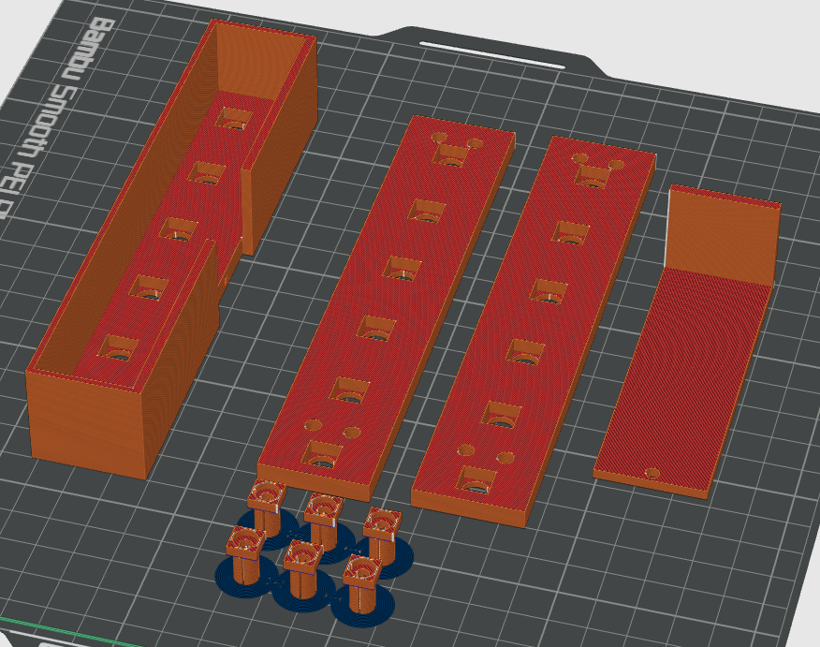

Final Result
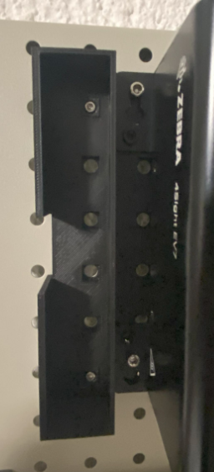 | 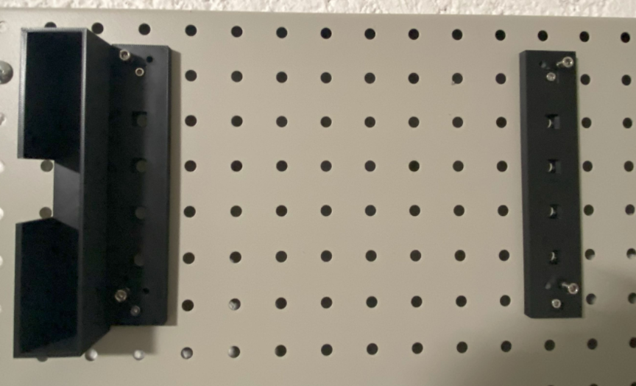

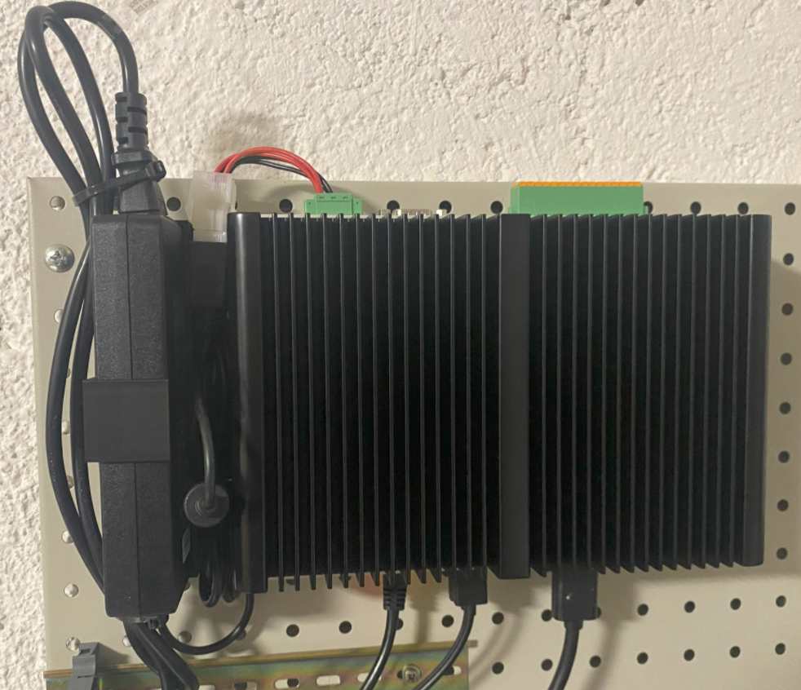

Reference

4Sight EV7
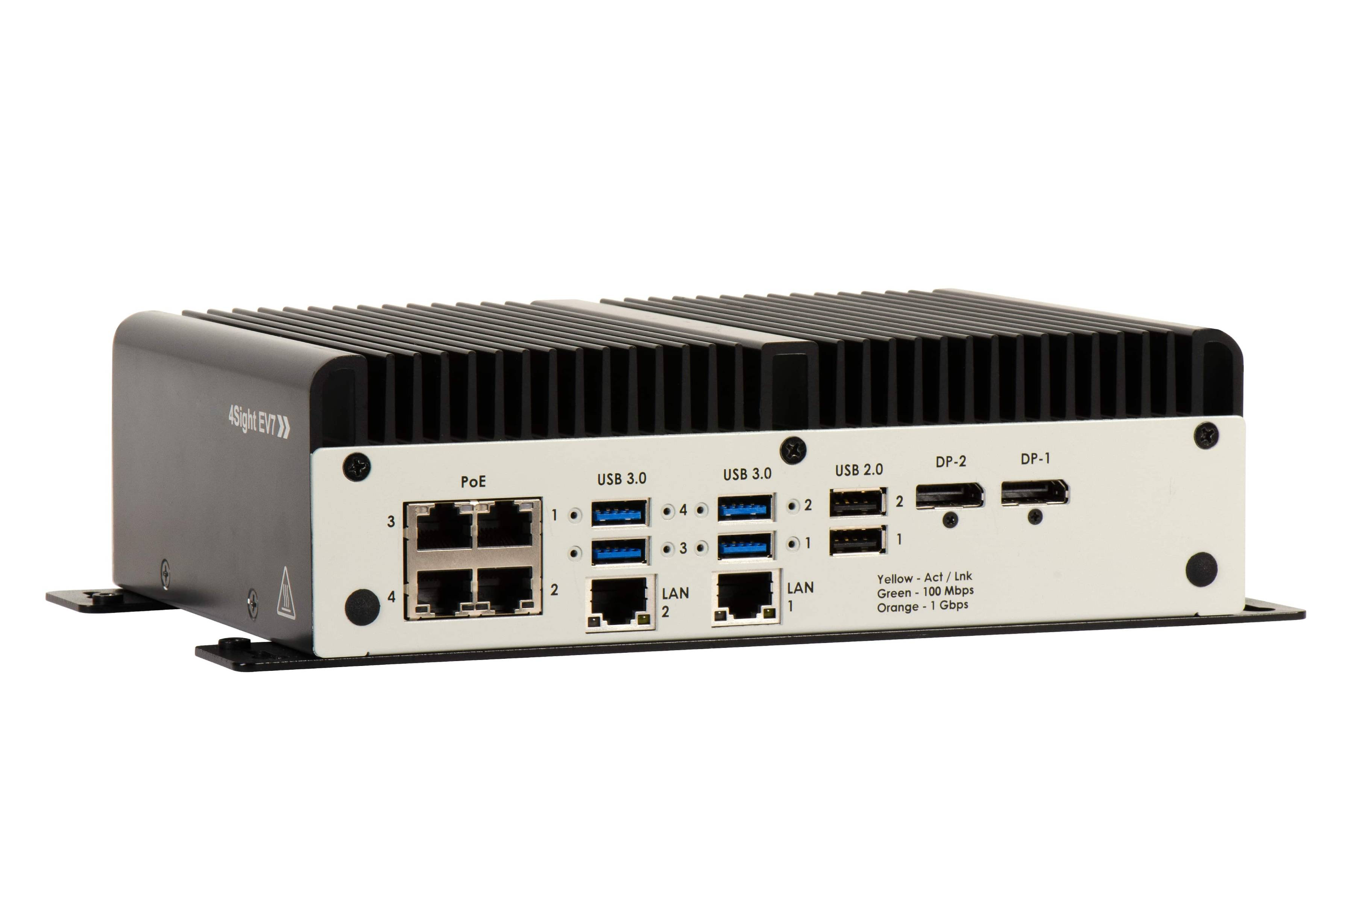

4Sight EV7 Drawings
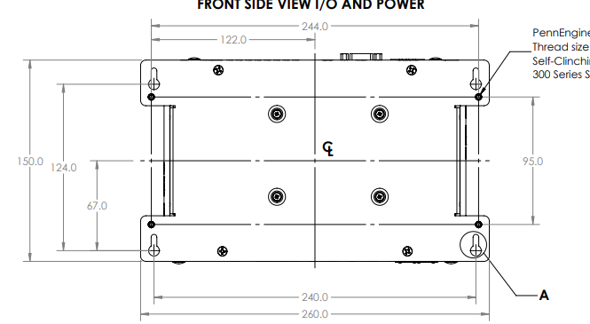

Expansion Anchor
This is used to lock a bracket to the Pegboard.
See the Expansion Anchor Project
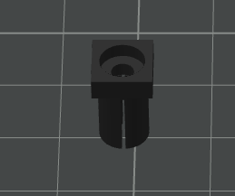 | 

